# Analysis results

This section commences by outlining spatial and temporal variances of vaccination uptake in England, to address how accessibility played a role in spatial variation in vaccination coverage in this study. It serves to support a spatial regression modelling approach for modelling spatially varying coefficients take into account spatial correlations in covariates. Thereafter, model performance and its findings are reported. Figure 1 presents COVID-19 vaccination coverage disparities in England that people aged 25 to 50 received their 1st dose uptake on 24 June 2021. The vast majority of MSOAs (90.2%) have an estimated uptake above than 50% reflecting the prosperity of the vaccination roll-out. Interestingly, there are lower levels of vaccination uptake in aged 25 to 50 in major cities, particularly Greater London and Birmingham. Figure 2 shows the temporal variance of vaccination uptake by age groups. It is important to recognise (as we noted earlier) that UK vaccination programme and deliver plans will drive geographic differences in vaccination coverage, as well as unequal spatial distribution of vaccine uptake in young adults.

Examining the spatial and temporal patterning of vaccine uptake for England, two observations stands out. Firstly, disparities in COVID-19 vaccination coverage was associated with delineation of urban areas and its adjacent neighbourhoods. In other words, there are significant geographic differences in vaccine uptake for young adults. Urban centres for those cities in London, Birmingham, and Liverpool is likely to have lower than average while remote areas have marginal difference between the overall average vaccine uptake in England (66.8%).

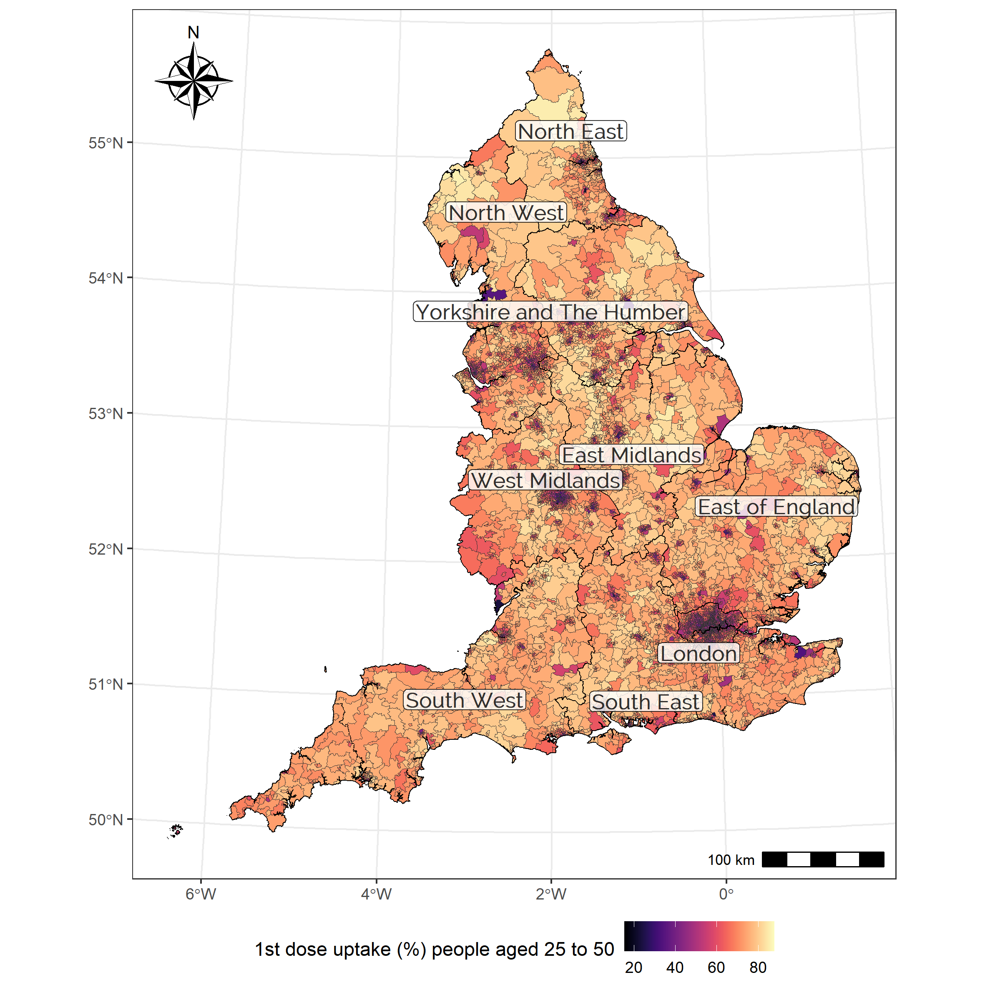

Figure . COVID-19 vaccination coverage on 24 June 2021 by MSOA level in England.

Or Below / Above 50% vaccine uptake map?

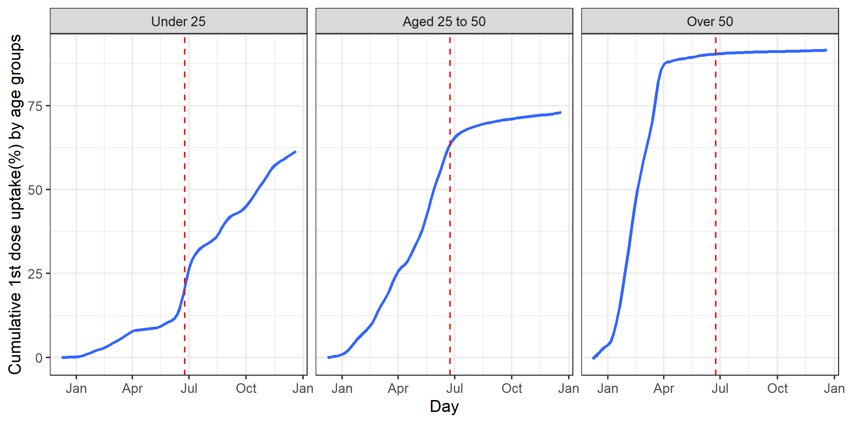

Figure . Temporal changes in cumulative vaccination uptake of 1st dose, by age groups.

Walk-in NHS vaccination sites have been operated since 25 June 2021 in England with any adults able to turn up and get vaccinated (<https://www.england.nhs.uk/2021/06/nhs-walk-in-vaccination-sites-open-up-in-grab-a-jab-weekend/>).

### Model performance

Table 2 provides the model fit for the negative binomial regression models. IRR (incidence rate ratios) is the exponential of the coefficient. It denotes the corresponding multiplicative change of influence arising from a one-unit change in the explanatory variable. For instance, share of households in lowest household income quintile at national level, an IRR value of 0.964 in negative binomial regression model controlling for spatial effects, would imply that an explanatory variable is associated with a 3.6% decrease (96.4%) in first dose vaccine uptake for England.

Table 2 also displays whether factors positively or negatively influencing vaccine uptake (IRR > 1)

* Share of the higher education qualification, lower middle class, part-time workers, median ages of the resident population, number of accessible vaccination centres by public transportation within 60 min, and the average vaccine uptake in adjacent areas (i.e., spatial lag).

Factors negatively influencing vaccine uptake (IRR < 1)

* Share of low-income households, household with no car, number of accessible vaccination centres by car (within 45min), and minor ethnic groups.

Additionally, Moran’s I was used to assess the spatial autocorrelation of the NB model’s residual value, and it allows us to investigate a Poisson regression approach for modelling spatial count data (see Table 1).

## Spatially varying coefficient modelling for vaccine uptake

* In overview, Spatially varying coefficients in covariates explain spatial differences in vaccine uptake for England (Table 3).
  + Figure 2 illustrates the spatial distribution of generated clusters using the SFCR model.
  + Table 4 described the characteristics contributing to vaccination uptake across England, and articulated inequalities in access to vaccines by clusters.
* Intermediate factors based on SFCR model estimation results, would have different influences on vaccine uptake by clusters (Table 3)
  + Consistent variables: Share of low-income, households with no car, part-time workers, and median ages of the resident population.
  + Intermediate variables: Share of the lower middle class, number of accessible vaccination centres by car (within 45 min) and public transportation (within 60 min). Subsequently, share of part-time workers and ethnic minority groups in a few groups.
* Inequalities in access to COVID-19 vaccines for England – categories (Table 4)
  + Outstanding accessibility (to vaccination centres) but below average vaccine uptake in G3 (London) and G7 (West County): those areas were shown to have above-average accessibility but had lower uptake.
  + Poorer accessibility to vaccination centres, but above average uptake in G1, G5, and G6: excess mortality was observed in the first wave of the pandemic in early 2020.
  + Lower than average accessibility will likely lead to poor vaccine uptake in G2 and G4.
    - Poor access to vaccination centres served as access barriers that may influence vaccine uptake.